Qualification
BTEC Level 3 - Applied Science
Center Name | Center Registration No
ABC Horizon Academy | 91667
Student name | Assessor name
Ziya selim | Mr. Tareq ZAINALDIN
Unit Number/Name
Unit 28: Sustainable Energy
Assignment number and title | Submitted on
- Impact of use of fossil fuels  - Alternative energy sources  - Benefits and disadvantages of the use of renewable energy | 31/03/2026

Student Declaration

Student signature: Date: Click here to enter a date.

Part A
Green Energy Technology Company
Visitor Information Guide
Understanding Fossil Fuels and Renewable Energy
Prepared by: Ziya Selim
Position: Trainee Energy Research Assistant
Introduction
During my work placement with a green energy technology company, I was asked to prepare information materials for visitors and members of the public. Due to increasing concerns about climate change, pollution and energy security, it is important to understand where our energy comes from and how it affects both people and the environment.
This guide explains the sources and uses of fossil fuels, the environmental and health impacts associated with them, and the role renewable energy can play in creating a more sustainable future. The information has been prepared for display in the company foyer and to help visitors better understand modern energy challenges. 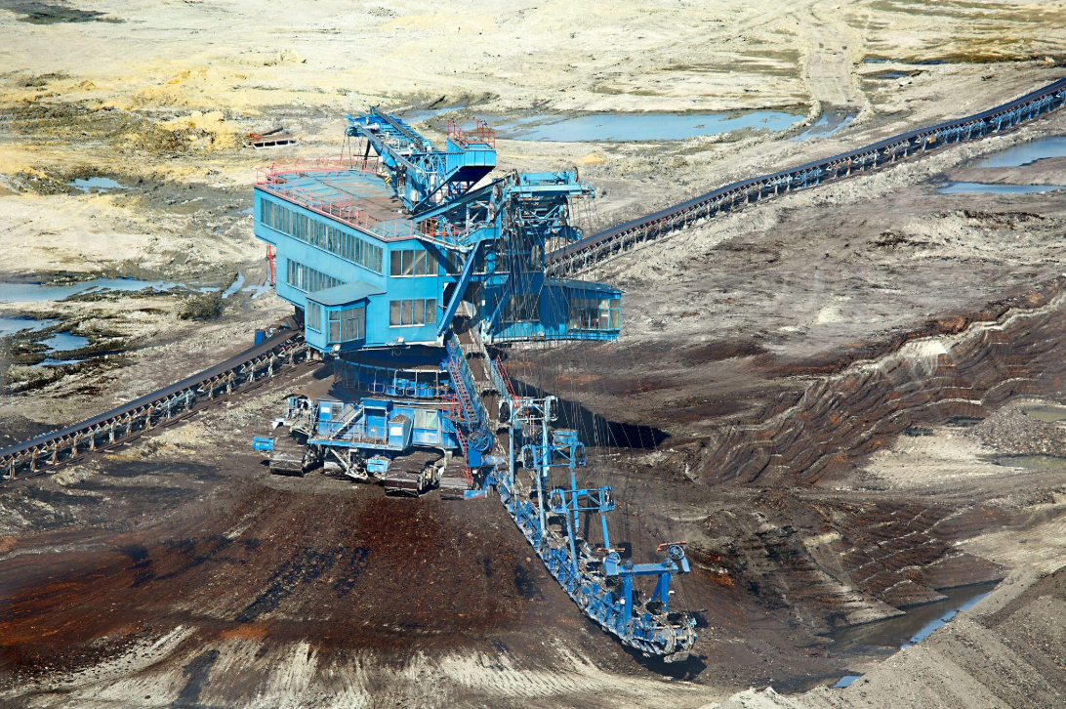
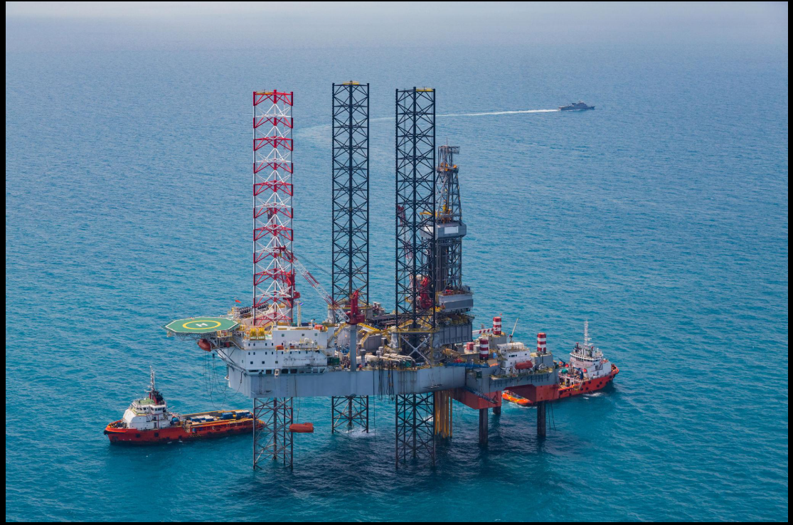

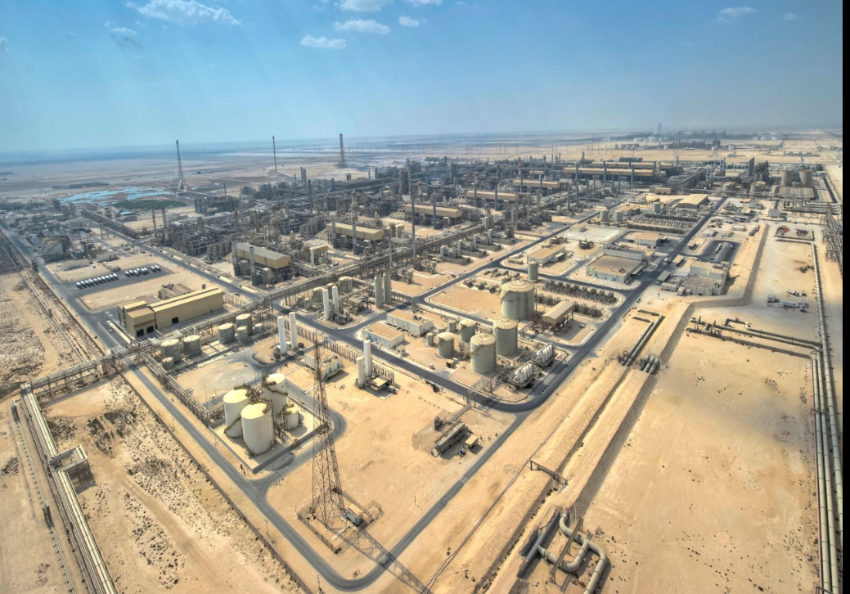

Part A
Fossil Fuels: Sources, Uses and Impacts
As part of my work placement with a green energy technology company, I was asked to prepare information materials for visitors about fossil fuels and their effects on society With extreme weather events becoming more common around the world it is important to understand where coal oil and natural gas come from how they are used, and how they can affect both the environment and human health.
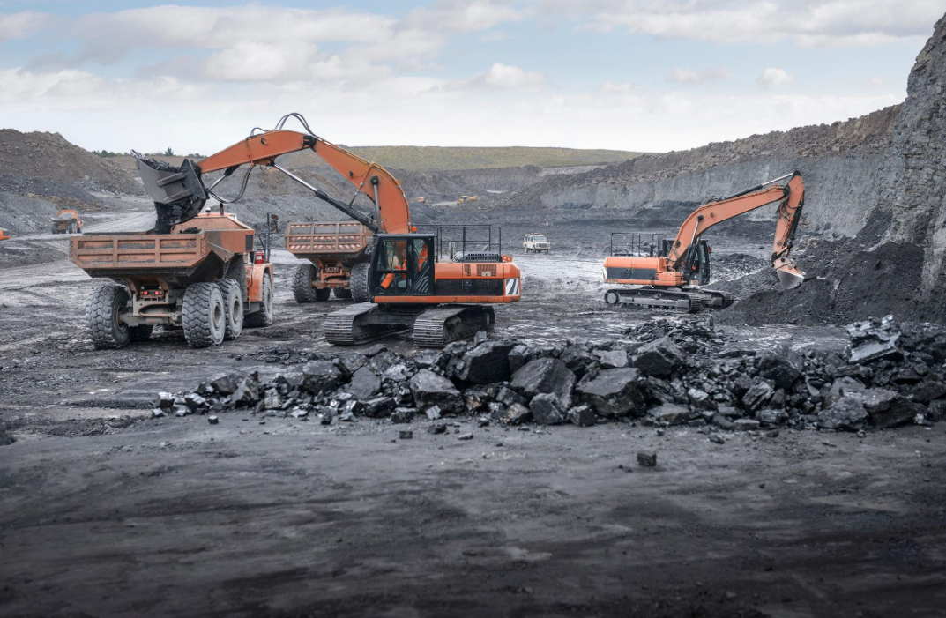
Sources and Extraction of Fossil Fuels
Fossil fuels were formed millions of years ago from dead plants and tiny organisms. Over time, heat and pressure underground changed these remains into coal, crude oil and natural gas.
Coal is found in layers called coal seams. It can be extracted using surface mining when it is close to the ground or underground mining when it is deeper below the surface.
Oil and natural gas are found deep underground beneath layers of rock. They are collected by drilling on land or at sea. In some areas, hydraulic fracturing (fracking) is used to release natural gas trapped inside rocks.

Uses of Coal, Oil and Natural Gas
Coal oil and natural gas are known used in many different ways they provide energy for homes transport and industry
Coal is mainly used to generate electricity and produce steel. It can also be processed into products such as coke, activated carbon and coal tar.
Crude oil is refined into petrol diesel and aviation fuel It is also used to make plastics medicines synthetic fibres and many everyday products
Natural gas is commonly used for cooking, heating and electricity generation It is also used in the production of fertilisers and other industrial chemicals
Fossil Fuel | Main Uses
Coal | Electricity generation steel production coke coal tar
Oil | Transport fuels, plastics, pharmaceuticals
Natural Gas | Heating cooking electricity generation fertilisers

Environmental and Ecological Impact
When we burn fossil fuels we release greenhouse gasses such as CO2, Methane, and Water Vapor into the atmosphere. These gases retain heat, creating a greenhouse effect, raising temperatures across the world.
Rising sea levels, droughts, heatwaves and more extreme storms can all be results of climate change. These changes can severely impact on ecosystem, agriculture and people worldwide.
Extraction of fossil fuels can also have a significant impact on the environment, removing vegetation through surface mining and destroys habitats. Oil spills can have negative consequences for sea life and pollution to water sources, whilst fracking requires vast quantities of water and may lead to more mini earthquakes and pollution of groundwater.
In my opinion the impact that fossil fuels have on the environment is arguably one of the biggest problems in the energy industry today. They may be dependable and provide ample energy, but the long-term impact to the natural environment and global climate is enormous

Impact on Human Health
Release of air pollutants into the atmosphere from burning fossil fuels may include pollutants like sulfur dioxide, nitrogen oxides, particulate matter and volatile organic compounds which may negatively impact air quality and respiratory health. It is possible that prolonged exposure to these pollutants may increase health risks in vulnerable individuals such as children, the elderly and those with respiratory conditions, to asthma, chronic bronchitis strokes and cardiovascular disease. It may be that there is presence of a number of toxic pollutants including Mercury, lead and arsenic that are present within the emissions of fossil fuels and that these have potential for serious harm on the health of individuals and the environment if released in large volumes. I believe that the reduction in these emissions must be a priority for reasons including the fact that improvements in air quality have been observed in many areas with a potential lowering in the strain on public healthcare resources. It may be that although Fossil Fuels continue to serve an important role in global energy cleaner sources of energy will serve to diminish a number of these public health concerns in the future.

Evaluation of Continued Fossil Fuel Use
Fossil fuels are vital because they produce consistent electricity for houses transport and industries the reason why countries still use coal, oil and gas is because infrastructure is already established and energy can be produced on a massive scale. Nevertheless fossil fuels are a finite source and the contribution it make to air pollution and climate change are immense even though they currently are a huge part of global energy demand investment is gradually being made to renewable energy technology in hope that environmental damage can be reduced and energy production can be made sustainable in the future. I believe that during the transition to renewable energy fossil fuels should still be used but should slowly be replaced with the advanced technology
------------------------------------------------------------------------------------------------

Sustainable Energy Assignment – Part B
As part of my work placement with a green energy technology company, I was asked to prepare information materials for visitors about renewable energy technologies This section explains how different renewable energy sources generate electricity compares their efficiency, and discusses the factors that affect their performance and cost
How Renewable Energy Generates Electricity 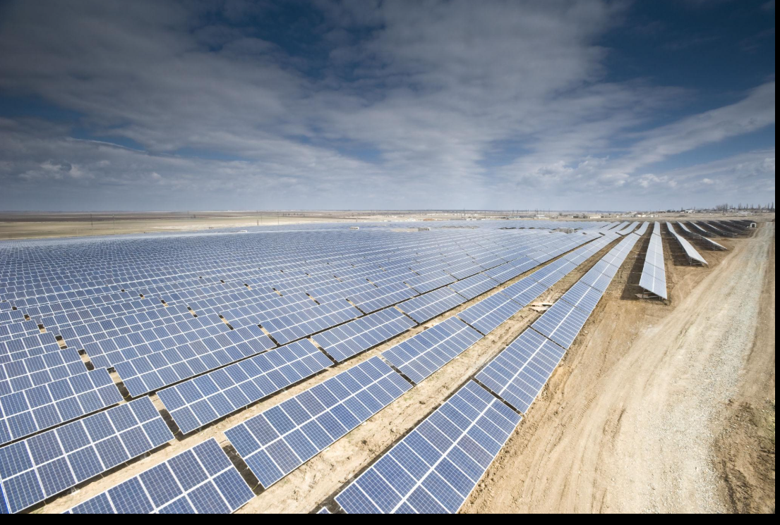
Renewable energy can be generated in several different ways using natural resources that are continuously replaced by nature.

Solar Energy
Solar energy is produced using photovoltaic (PV) panels These panels absorb sunlight and convert it into electricity. Solar power is clean and renewable but the amount of electricity produced depends on weather conditions and the amount of sunlight available.
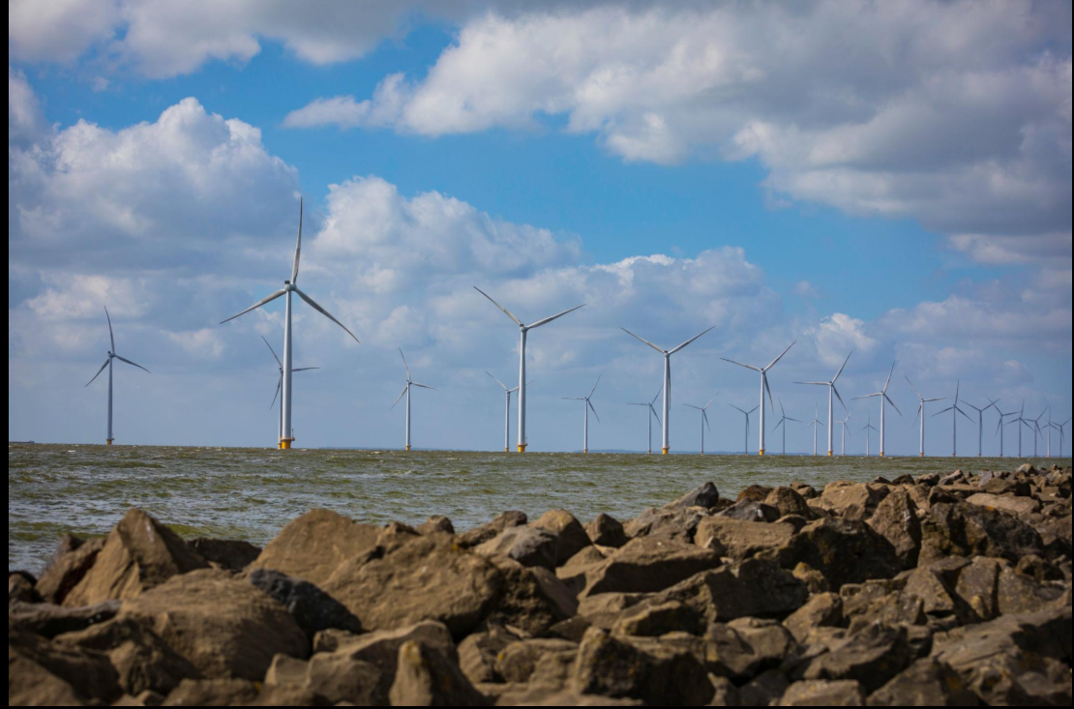
Wind Energy
Wind energy is generated using wind turbines. When the wind blows, the turbine blades rotate and drive a generator that produces electricity. Wind power is a popular renewable energy source because it produces electricity without releasing greenhouse gases.
Hydroelectric Energy
Hydroelectric power uses moving water to generate electricity. Water flows through turbines, causing them to spin and power a generator. Hydropower is one of the most efficient renewable energy sources, although dams can be expensive to build

Biomass Energy
so biomass energy is produced from organic materials such as wood, plant waste and agricultural residues These materials are burned or processed to release energy that can be used to generate electricity. Biomass can reduce waste but it still produces some emissions when used as fuel.
Energy Source | Main Fuel | Main Advantage | Main Disadvantage
Solar | Sunlight | Clean and renewable | Depends on sunlight
Wind | Wind | No fuel required | Depends on wind speed
Hydroelectric | Moving water | Very efficient | High construction cost
Biomass | Organic waste | Uses waste materials | Produces emissions
Nuclear Energy
Nuclear energy creates electricity through nuclear fission. Uranium atoms are broken down creating enormous energy. The heat is used to create steam, which is then used to turn the electricity generators. One advantage of nuclear energy is the large quantities of electricity that can be produced while low greenhouse gases emissions are released. Electricity can also be continuously produced and thus the energy supply is constant. Disadvantages of nuclear power include the cost of the plant and safety precautions needed as well as waste which must be stored for years, not to mention the social and environmental affects of accidents although this is extremely rare. Nuclear power may supply low-carbon electricity however costs and waste issues must be considered
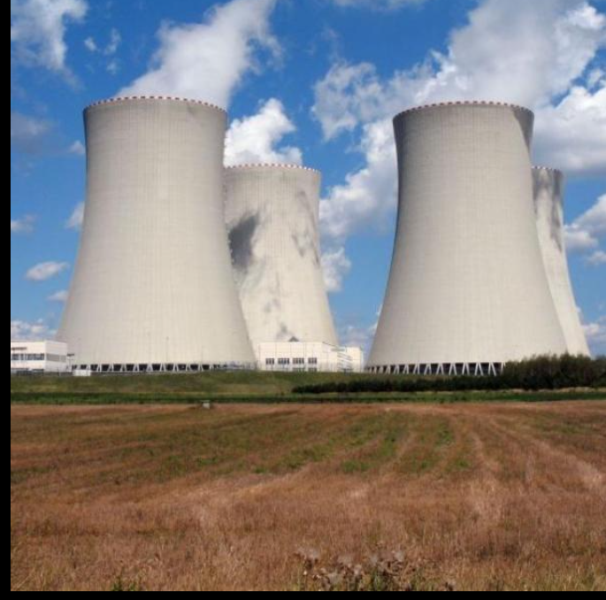
Factors Affecting the Efficiency of Renewable Energy Generation
The efficiency of renewable energy systems depends on several economic and operational factors. One of the most important factors is the cost of construction. Building solar farms, wind farms and hydroelectric power stations requires a large initial investment, which can affect whether a project is financially viable.
Maintenance also plays an important role. Wind turbines, solar panels and hydroelectric equipment must be regularly inspected and repaired to ensure they continue operating efficiently. Poor maintenance can reduce electricity generation and increase operating costs.
Environmental conditions have a major impact on performance. Solar panels work best in areas with high levels of sunlight, while wind turbines require consistent wind speeds. Hydroelectric power stations depend on reliable water supplies. As a result, the same technology may perform differently depending on location and climate.
In my opinion, environmental conditions are often the most important factor because even the most advanced technology cannot generate electricity efficiently if the natural resource is unavailable. For this reason, renewable energy projects must be carefully planned to match local conditions.

Factor | Effect on Efficiency
Construction Cost |  | High costs can limit development
Maintenance |  | Poor maintenance reduces performance
Weather Conditions |  | Affects solar and wind output
Water Availability |  | Affects hydroelectric generation

Technological Improvements
There have been some developments in recent technology that contribute to renewable energy Turbines currently are bigger and more efficient in blades that capture more energy from wind and convert into electricity more electricity Solar panel technology has also improved greatly and photovoltaic panels can absorb more energy from sunlight making solar energy far more efficient now compared to previously. Renewable energy also uses battery storage systems that allow electricity generated by wind or solar panels to be stored to be used at other times when electricity generation levels are lower, addressing the problem with the variability in sun and wind. I think the increase in the technology of batteries will affect renewable energy systems more than any of the other improvements due to its ability to store energy making it reliable and not wasted.
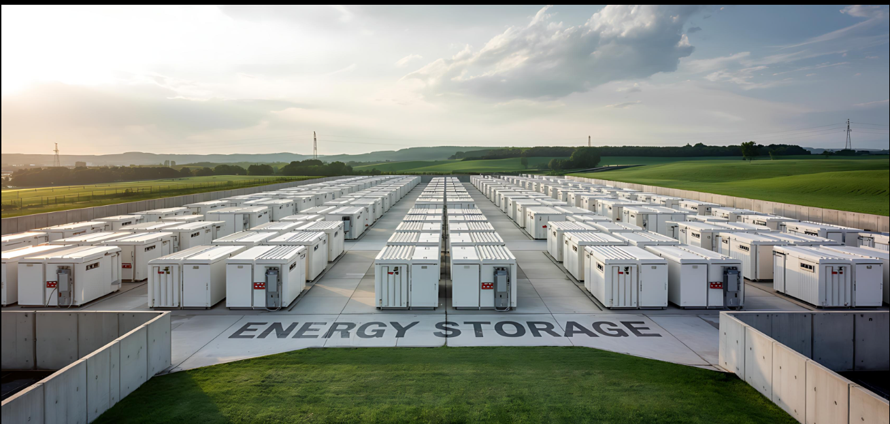

Levelised Cost of Electricity (LCOE)
LCOE or Levelised Cost of Electricity, is used to analyze the lifetime cost of generating power using various technologies. It is the average cost of electricity production over the total lifecycle of a power station.
The calculation takes into account factors such as construction costs, maintenance costs, operational costs, fuel costs, and total electricity production. This allows different sources of energy to be analyzed together.
For some renewable energy sources, such as solar and wind, high initial installation costs need to be weighed against very low fuel costs, due to free natural sources of sunlight and wind. Thus, renewables may offer advantages over long periods of time.
I feel LCOE provides a valuable tool for use by government and business when deciding on sources of energy based on their long-term value not just initial installation cost.

Energy Source | Construction Cost | Fuel Cost | Long-Term Cost
Solar | High | Very Low | Low
Wind | High | Very Low | Low
Fossil Fuels | Medium | High | High
Nuclear | Very High | Low | Medium

Comparison with Fossil Fuels and Nuclear Power
Renewable energy sources are becoming increasingly competitive when compared with fossil fuels and nuclear power. Fossil fuel power stations often have lower construction costs, but they require a continuous supply of fuel such as coal, oil or natural gas. These fuel costs increase the long-term cost of electricity generation and contribute to greenhouse gas emissions.
Nuclear power stations can generate large amounts of electricity with low carbon emissions, but they are extremely expensive to build and maintain. They also produce radioactive waste that must be managed safely for many years.
Renewable energy technologies such as solar and wind have higher installation costs than some fossil fuel systems, but their operating costs are generally much lower because they use free natural resources. As technology continues to improve, renewable energy is becoming more reliable and cost-effective.
In my opinion, renewable energy provides the best balance between environmental sustainability and long-term economic benefits. Although some renewable technologies depend on weather conditions, advances in energy storage are helping to overcome these limitations.

Energy Source | Carbon Emissions | Fuel Cost | Reliability
Solar | Very Low | None | Medium
Wind | Very Low | None | Medium
Fossil Fuels | High | High | High
Nuclear | Very Low | Low | High

------------------------------------------------------------------------------------------------
Part c
Public Perceptions of Renewable Energy
As part of my work placement with a green energy technology company, I was asked to prepare information materials about public views on renewable energy. Many people support renewable energy because it can reduce pollution and greenhouse gas emissions, but there are also concerns about costs land use and the impact of energy projects on local communities

Social Factors
Renewable energy projects also provide job opportunities, ranging from engineering to installation and maintenance of renewable energy installations. Many wind farms, solar power plants and hydro-electric plants often need skilled workers, which are then sourced locally and boost the economy. Renewable energy provides energy security as countries can produce their electricity from resources which are available to them locally as opposed to reliance on imports of oil gas and coal. From the point of view of the general public, they would welcome renewable energy as it provides jobs and does not involve relying on imports of energy.

Environmental Factors
When it comes to the environment renewable energy is a lot better than fuels. Solar panels and wind turbines make electricity without burning fuel, which means they do not produce a lot of greenhouse gas emissions. This helps slow down climate change. However renewable energy projects can still hurt the environment. Big hydroelectric dams can disrupt rivers. Affect fish. Wind turbines can hurt birds and bats.. Large solar farms can take up a lot of land which can hurt local animals.

Financial Factors
In terms of the costs, most renewable energy systems are expensive in the first place. It costs a lot to invest in buildingwind farms, solarpower plants andhydro-electric dams. However once they are up and running, they are quite cheap to run. This is because wind, water and the sun which power most renewable energy sources, are free. Therefore renewable energy could benefit economy in the long run.

If you look at different types of renewable energy then Solar energy is one of the cleanest. It converts sunlight into electricity and does not have any emissions.. The effectiveness of Solar power is weather dependant.

Wind energy also forms another one of the types of renewable energy. A large amount of electricity can be generated in areas where wind is prevalent, by the use of wind turbines. A low cost energy for running. This may make a great deal of noise and an intrusion of the view.. Some animals in some areas are impacted Hydroelectric power is one of the efficient types of renewable energy. It makes electricity from flowing water which's reliable.. Hydroelectric dams can hurt the environment and even force people to move.

Biomass energy uses materials, like waste or crops to make energy. It can be useful for recycling waste and providing a renewable fuel source Burning biomass still produces carbon dioxide Making a lot of biomass can take up a lot of land.

Geothermal energy uses heat from the Earth to make electricity or provide heating. It produces few emissions and provides a consistent energy supply It is only available in certain areas where there is enough underground heat.

Public Opinion on Renewable Energy
Public attitudes towards renewable energy are generally positive because many people see it as a cleaner alternative to fossil fuels. Solar panels and wind turbines are often supported because they help reduce greenhouse gas emissions and improve environmental sustainability.
However some people have concerns about the cost of renewable energy projects and their impact on local communities wind farms may be criticised because of noise and visual impact, while large solar farms and hydroelectric projects can affect land use and wildlife habitats.
Overall, public opinion tends to support renewable energy although opinions may differ depending on local environmental, social and economic factors

Energy Source | Public Support | Common Concerns
Solar | High | Land use, installation costs
Wind | High | Noise, visual impact
Hydroelectric | Moderate | Habitat disruption, relocation
Biomass | Moderate | Emissions, land use
Geothermal | Moderate | Limited locations, drilling costs

When we compare energy and biofuels they both have good and bad points. Nuclear power plants make a lot of electricity with few emissions. They are also stable and consistent.. They produce radioactive waste that needs to be stored safely.. Nuclear accidents can be very bad for the environment.

Biofuels are made from materials like crops or plant waste. They are considered renewable because the materials can be grown again. Biofuels can reduce our reliance on fuels especially for transportation.. Making biofuels can take up a lot of land and compete with food production. It can also hurt the environment.

Conclusion
Renewable technologies are beneficial to society in social, environmental and economic terms. Such technologies reduce greenhouse gas emissions, improve energy security and create employment. But there are a number of disadvantages, such as high installation costs, issues concerning land use and wildlife impact.
When comparing the different renewable energies I think that solar and wind energies are the two that attract most of the public interest, as both of these are the most beneficial in terms of environment and running costs. I think as time goes on technology will improve and become more accessible allowing renewable energies to be even more influential in meeting our energy needs in the future.

References:
• U.S. Department of Energy – Levelized Cost of Energy Analysis
• Renewable Resources Coalition – Alternative Energy Sources
• GreenMatch UK – Alternative Energy Sources Guide
• Council on Foreign Relations (World101) – Sources of Energy Comparison
• Forbes – Renewable Energy Trends
• International Energy Agency (IEA)
• International Renewable Energy Agency (IRENA)
• National Geographic – Renewable Energy Resources
• Encyclopaedia Britannica – Fossil Fuels and Renewable Energy
• World Nuclear Association

